CST2355 – Database Systems Lab Assignment 3

Student Name: Nouraldin Hassan

Student ID: 041054019

Student email: hass0443@algonquinlive.com

# Hand-in:

1. The lab assignment will be graded out of a maximum 4 points.
2. This template should be used to submit your lab assignment.
3. Make sure you have enough screenshots to completely document that you have completed all the steps.

# Activities (Steps):

1. In this lab you will be using the Microsoft SQL Server 2019 database management system, and the MS SQL Server Management Studio (Version 18). The first step is to get the software installed.
   1. Follow the instructions below to install MS SQL Server 2019 and the SQL Server Management Studio 18
      1. Navigate to: <https://www.microsoft.com/en-ca/sql-server/sql-server-downloads>

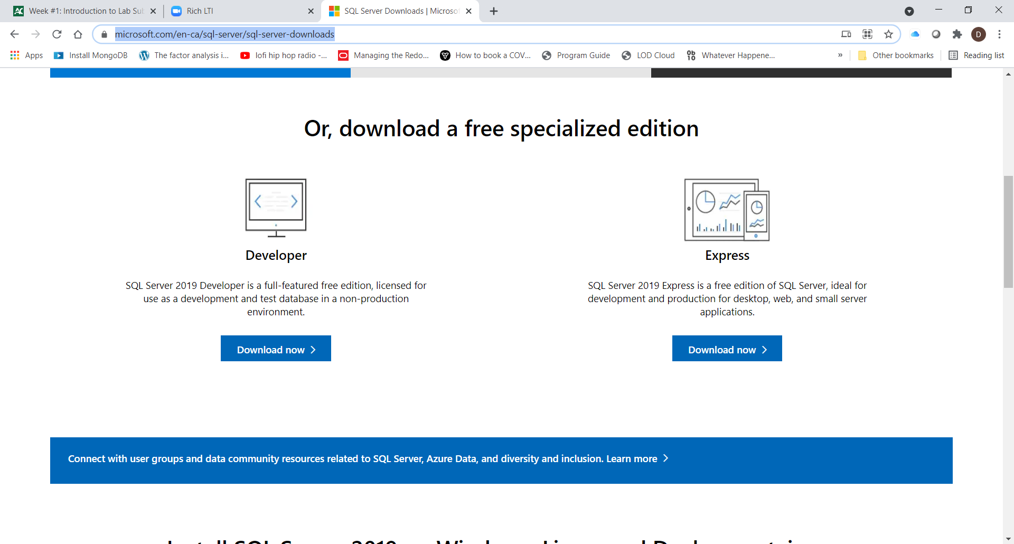

* + 1. NOTE: Make sure you take a screenshot of the confirmation screen that shows all of the configuration folders, when you download and install the Developer edition. (Use the “Basic” installation configuration).

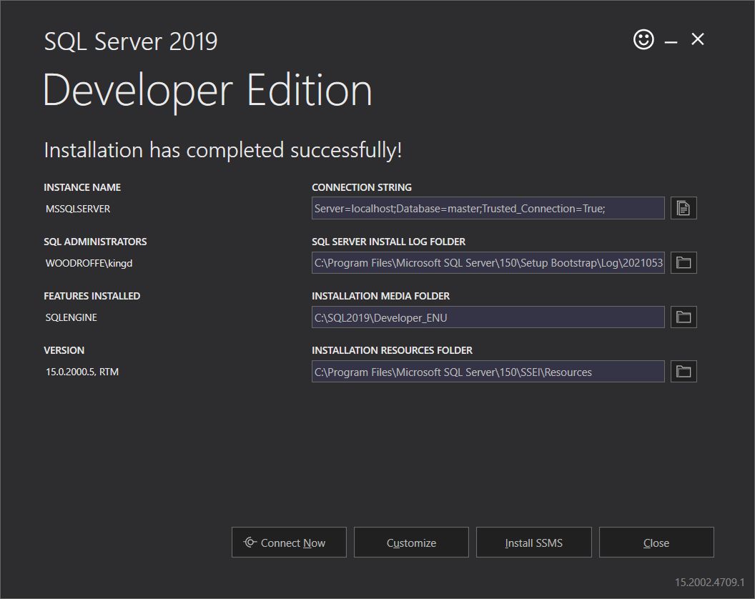

* + 1. Paste YOUR installation confirmation screen here:

1. On the confirmation screen, select “Install SSMS” to install the SQL Server Management Studio.
   1. You need to download Version 18.9.1 and then run the setup file.
2. When complete, open the SQL Server Management Studio in Windows.
   1. The first time you open the tool, save the launch screen – it shows your instance name. Here is mine.

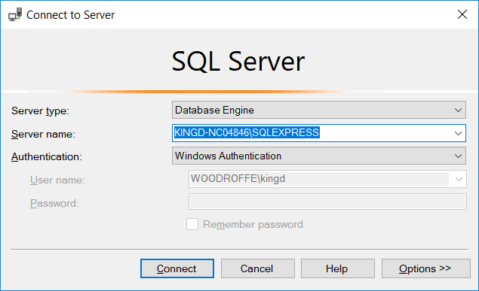

Paste your screen here:



1. Connect to your server
   1. Once launched, Select “Databases” and create a new one (right-mouse click, etc.) named “lab3”.
   2. Select lab3 and right-mouse click it to get the Tasks menu and select “Import Data”.
   3. Import the MS-Excel worksheet from lab2 containing the hobby data. (lastname, firstname, hobby) into a new table and rename the table “HobbysRaw” (see: <https://stackoverflow.com/questions/39610133/how-to-import-an-excel-file-into-sql-server> )
   4. Create a New query, and execute it to show all the data in the imported table. Here is my table:

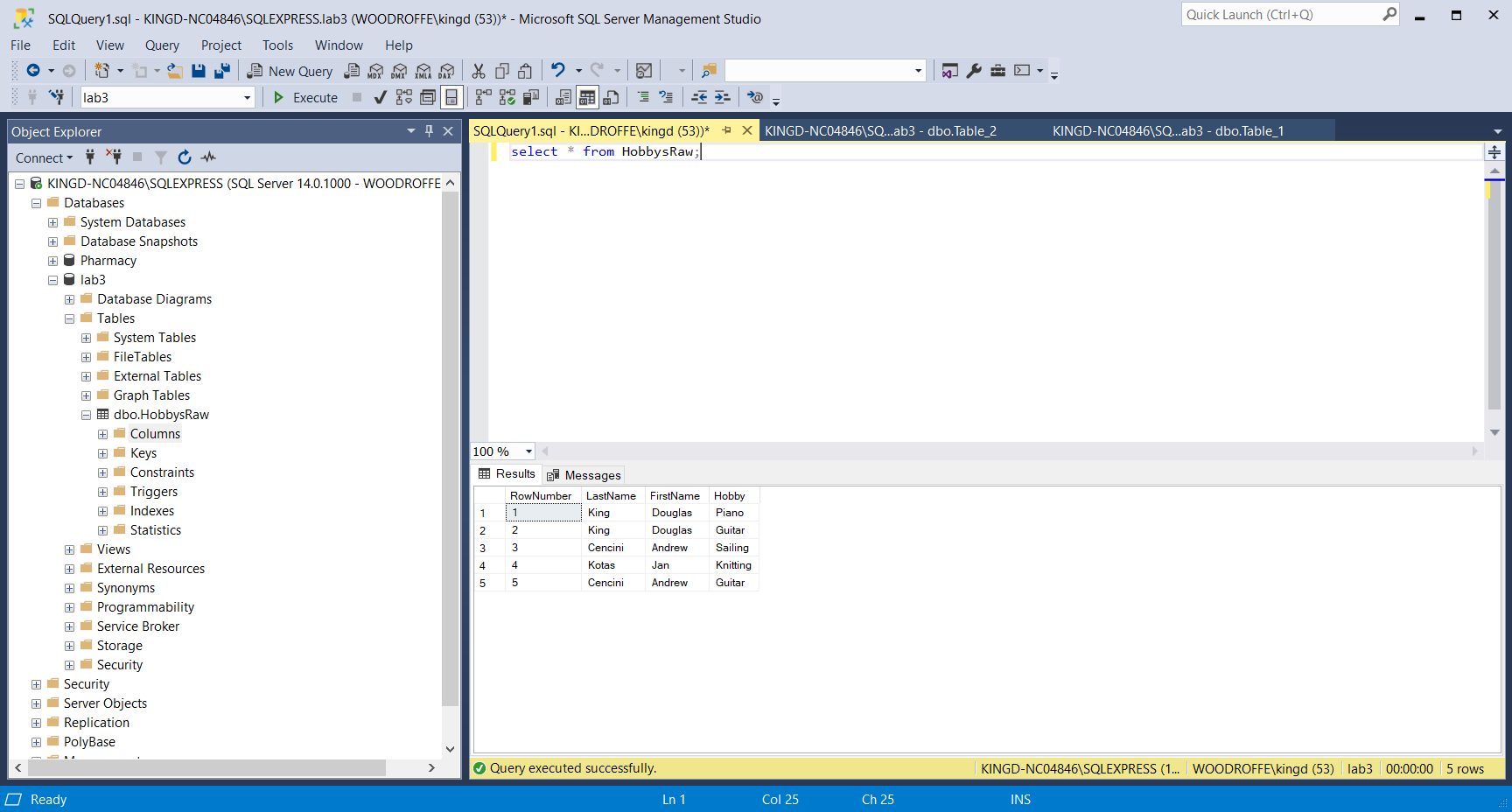

Paste your screen shot here:

Note: I tried all of the excel versions and it still didn’t work.

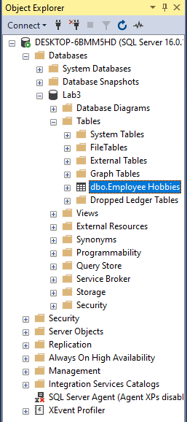  
Note: I decided to “Import Flat File” instead, and it works without problems.

1. Now you will “Upsize” your version of the Northwind database from lab2.
   1. FIRST MAKE A COPY OF YOUR ACCESS DATABASE FROM LAB2. Save it as “NorthwindForLab3”,
   2. Navigate to the lab3 database and again right-mouse click and select Import Data from the Tasks sub-menu.
      1. Select the data source as your NorthwindForLab3.accdb file. (You can use the advanced options to choose a blank username and password for the connection).
      2. Once connected, select all the tables in the source database:

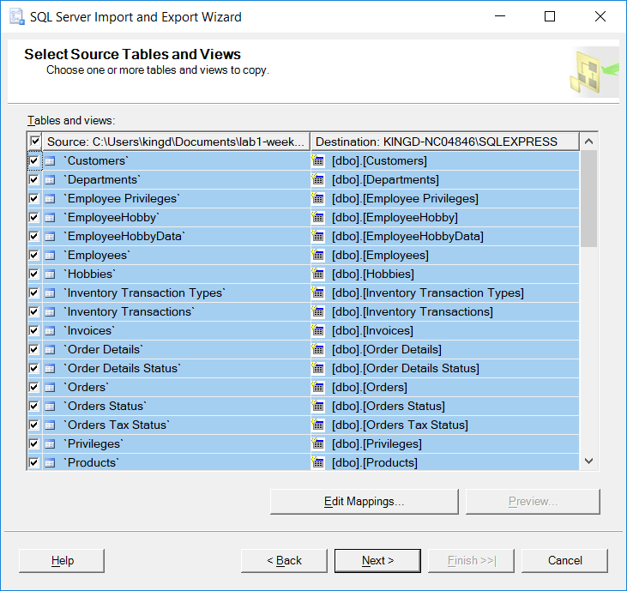

* 1. Accept all the defaults (don’t adjust the meta-data) and “Next” until “Finish”, at which point all the data tables will be imported! Here is my success message:

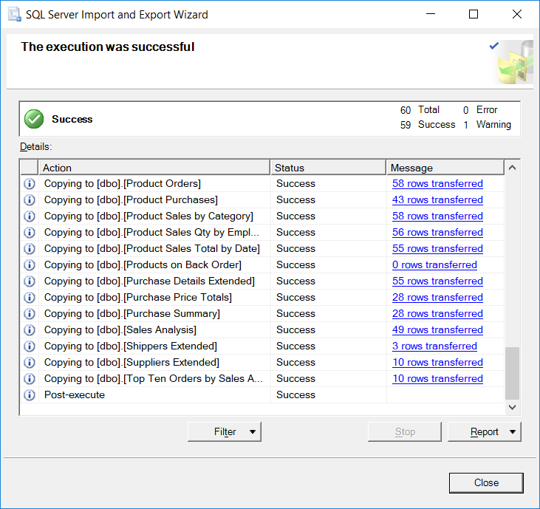

Paste your screenshot here:

Note: the process worked.

* 1. Select Tables in the Object Explorer and Refresh the list (F5). Paste a screen shot showing your list of imported tables in the object explorer (NOT the Wizard view above):
  2. Create a query to view all the data in one of the tables (pick one with some data….) and show the result of executing the query. Paste your screen shot below.

1. Once you have embedded all of your screenshots, submit the file in Brightspace and you’re done!  
     
   Graphical user interface, application, table

   Description automatically generated  
   Note: Example use of query for customers after lab3 Northwind database import